**Load balancing with Nginx - Tomcat**

What is Load balancing: -

Load balancing is nothing but process to distribute the load to the various resources.

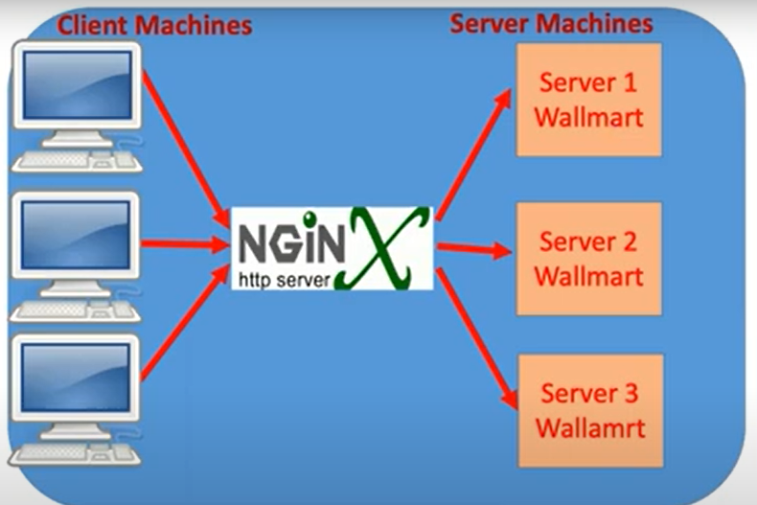

In above Picture we can find 3 servers are there. we have Deploy the same application in to the 3 servers to provide the high availability and reduce the down time of the application.

Using the any Http server or load balancing server we can destitute the load into many servers, for that we have to install the Nginx server and configure that server URLs into Nginx server.

Requirements to setup: --

* One web server (Nginx)
* Three Application Servers

Install the Nginx and Install Tomcat Servers in3 Linux Servers so that request will come to that Nginx server and it is going to route to any one of the servers.

Once we launch the (Instance) Linux server, we have to Install the Nginx server in this Linux.

**#Login as root user and execute the below command for install nginx http server.**

sudo su -

yum install wget -y

wget <https://nginx.org/packages/rhel/6Server/x86_64/RPMS/nginx-1.18.0-2.el6.ngx.x86_64.rpm>

yum install nginx-1.18.0-2.el6.ngx.x86_64.rpm

systemctl start nginx

systemctl enable nginx

nginx -V

now we can to access Nginx sever with the using the <http://Ip> addres:80

Note: -- 80 Is the Default port Number of the Nginx server.

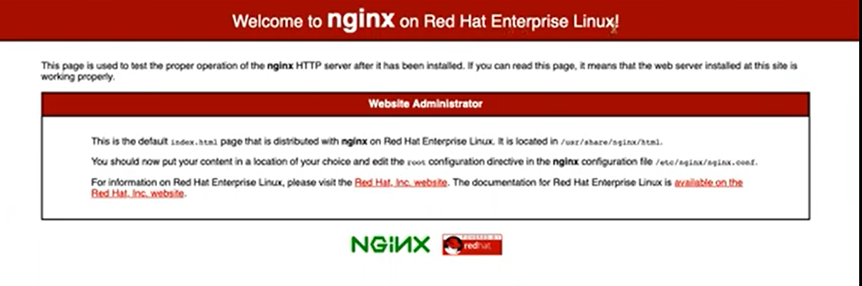

Now we have to configure the 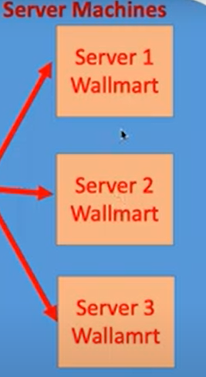 server URLs Into the Nginx Now we can able to access the applications with the Nginx URL.

Step 2: now we have to Install and Start the 3 (Tomcat servers).

Tomcat server Installation

1.Launch the Ec2-Instance with 2gb Ram (t2-micro)

connect the server using any ssh Tools

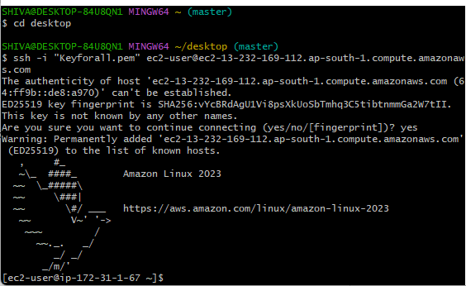

2.Switchh to the root user

sudo su –

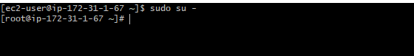

3.Install the java

sudo yum install java-11-amazon-corretto-devel -y

after java installation check the java version: javac –version or java –version

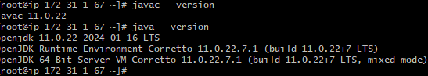

4.Swith to opt Directory: cd /opt 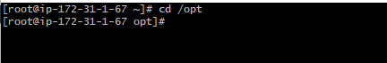

5.Install the Apachi Tomcat:

wget <https://dlcdn.apache.org/tomcat/tomcat-9/v9.0.86/bin/apache-tomcat-9.0.86.zip>

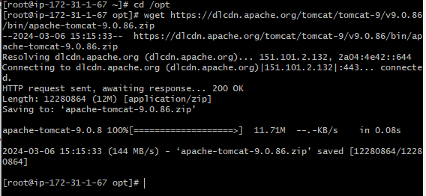

6.Unzip the file using unzip apache-tomcat-9.0.86 then Execute the ls Command

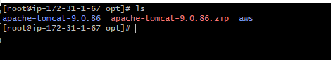

7.we can able to see the list of the Tomcat Directory files

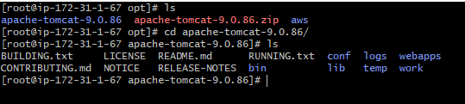

8.Then go to the bin Directory by using cd bin Command and execute the chmod command for the

Permission of .sh files in the bin Directory

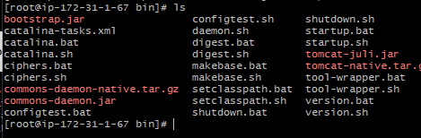

Chmod u+x *.sh

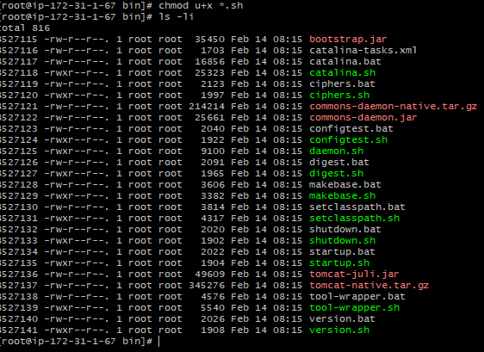

Then create the one soft link to access any whare in the server

To start the Tomcat

ln -s /opt/apache-tomcat-9.0.86/bin/startup.sh /usr/bin/startTomcat

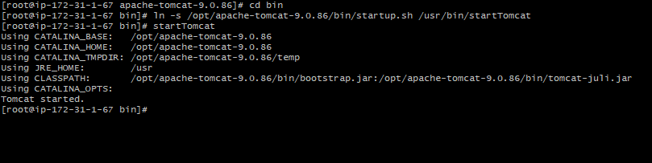

To Stop the Tomcat

ln -s /opt/apache-tomcat-9.0.86/bin/shutdown.sh /usr/bin/stopTomcat

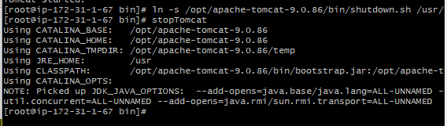

Then Change the Inbound Rule in the amazon Tomcat Server

1. Go and click on the Security option

And click on the launch-wizard-83

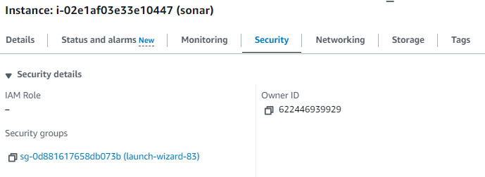

Click on the Edit Inbound rule option and Click on the Add rules

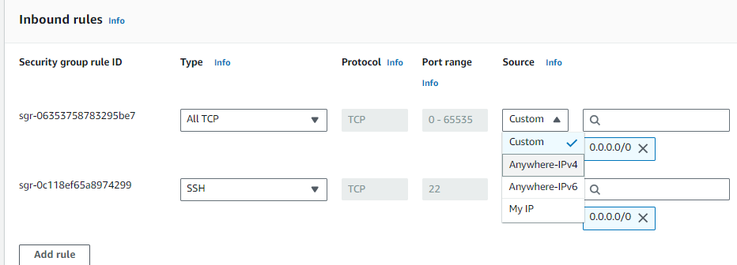

Then Switch to conf Directory: cd Conf

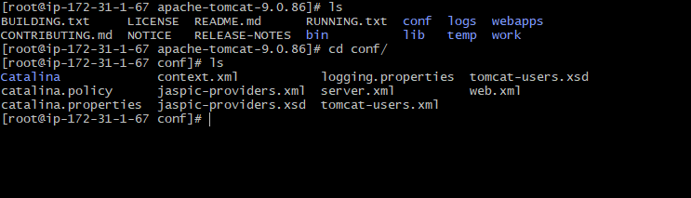

Then go to the vi tomcat-user-xml file and add the users



And save that using: -------- :wq Command

Then go to the webapp directory

cd webappa

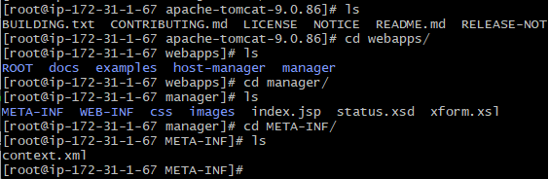

Then edit the context.xml file and commit the line

<!—-

-->

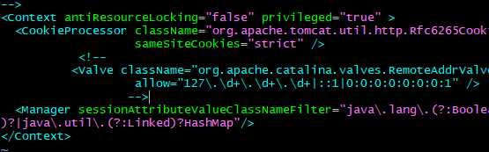

Using the Public Ip address <http://13.232.169.112:8080/>

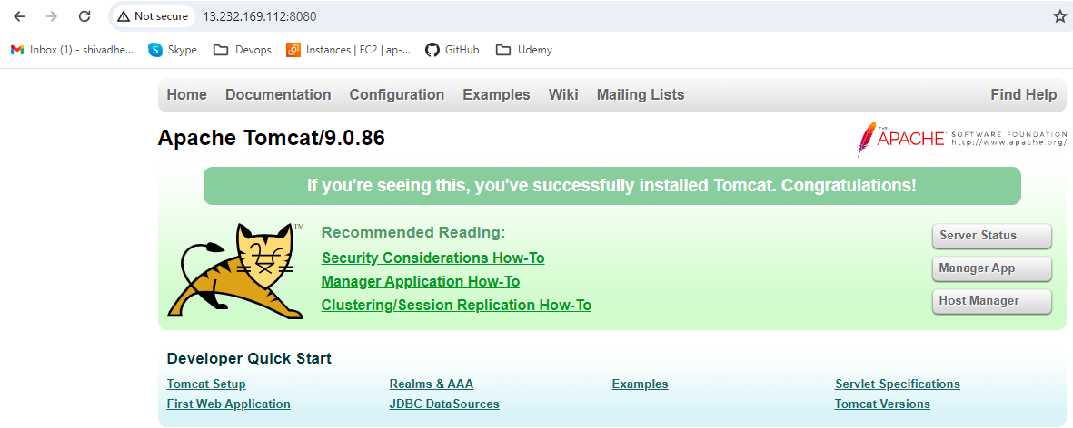

Now Nginx server and all 3 Tomcat servers are ready.

Go to the Linux server where Nginx is Installed. First, we can take that Nginx configuration file as a backup.

* cd /etc/nginx/
* cd nginx
* ls

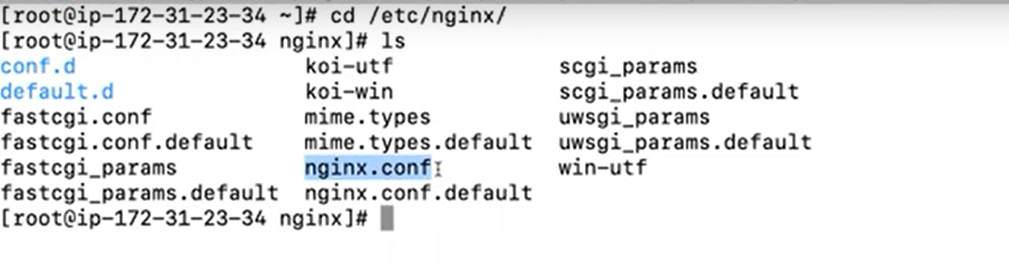

Now we can see the nginx.conf. this is the default Path of our nginx configuration and this is the file.

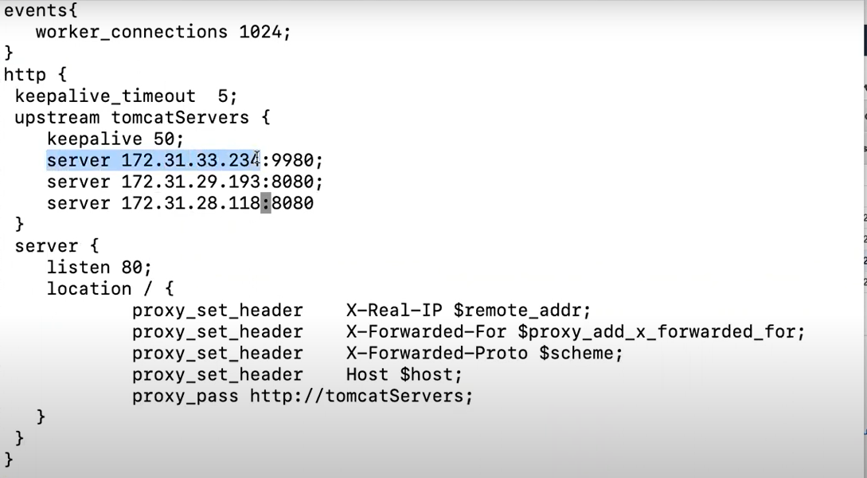

Now 3 tomcat server Id address in the nginx.conf file.

* Execute the nginx -t Command to check the configuration file.

Now reload the configuration 🡪 nginx -s reload

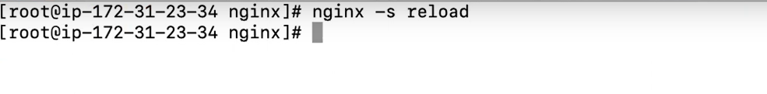

Restart the Nginx server for that-🡪 systemctl restart nginx

🡪 setsebool -P httpd_can_network_connect true

One we execute this command it is going to allow you access that URL.

Default load balancing method is round robin Algorithm

Request are Distribute to across the server.

🡪How to Down the server Due to less uses

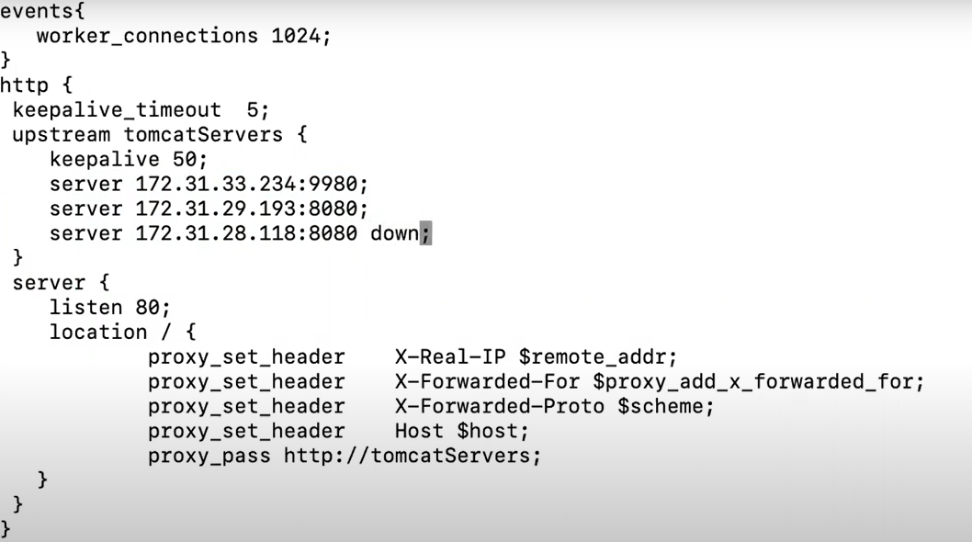

If we made any configuration –we have to restart the server by using the systemctl restart nginx command then only it is going to reflect the changes.